CA3 ASP.Net Core Blazor Project

BLAZOR WEB PAGE USING WEBAPI

X00160711 Cianan Nicolai

2022

Contents

Introduction 2

Description of System 2

Screenshots 2

URI for Deployed App 3

Description of Testing 3

Code Quality & Metrics 3

GitHub Repo URL 3

# Introduction

An ASP.Net Core Client Side Blazor application is required which provides simple interactive functionality to display data from a public API and provide other simple features. A Single-Page Application is required implemented using Blazor (client side). 1/2 pages will suffice. The application should interact with a public API of your choice (GET only). The API should be RESTful (JSON), a public open API (with no authentication) is fine.

## Description of System

This project uses the free API chucknorris.io to generate facts also known as jokes about Chuck Norris. The features that were intended to deliver upon where random jokes which is done on the first page, random joke by category selection and a search functionality to look through the jokes that contain that particular word.

Bootstrap for blazor otherwise known as [blazorstrap.io](https://blazorstrap.io/) was used to help with some quick basic formatting.

.Net packages that were used were the following, [Microsoft.AspNetCore.Http](https://www.nuget.org/packages/Microsoft.AspNetCore.Http) and [newtonsoft](https://www.newtonsoft.com/json).

## Screenshots

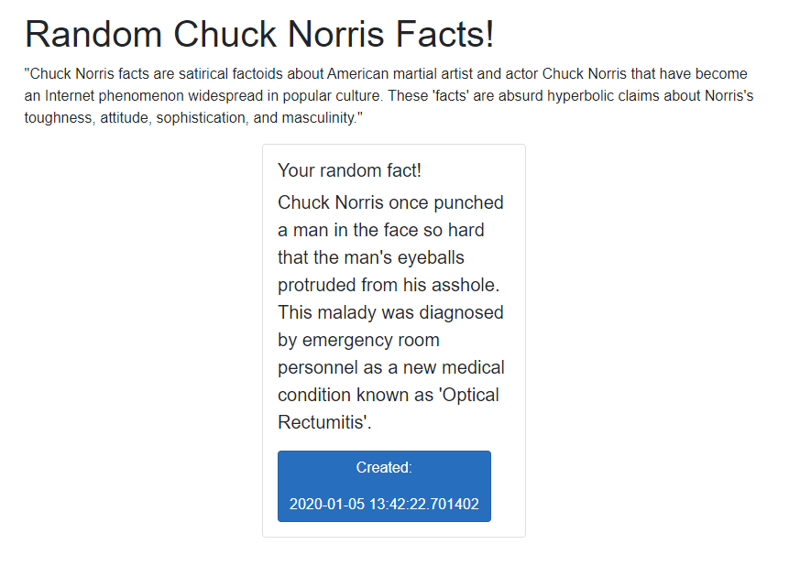

Figure Random Chuck Norris Facts

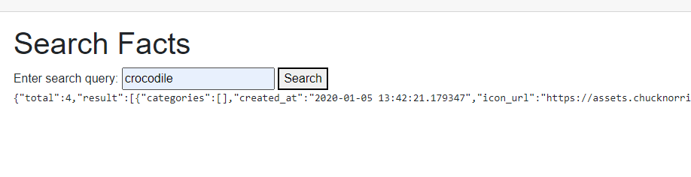

Figure Search Chuck Norris Facts, as of writing this I struggled to display it correctly.

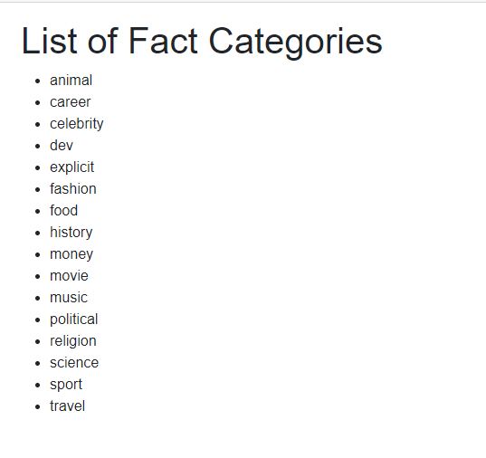

Figure A list of all the categories that the website has,

## URI for Deployed App

## Description of Testing

## Code Quality & Metrics

The facts are in a json format and not a json array which proved problematic when pulling lists of the items.

## GitHub Repo URL

https://github.com/CiananNicolai/ASP.Net-Core-Blazor-Project-API